Chapter 3 Tricks

A brief introduction to tricks

Trick in the world of Lasertank is just like magic in the world of “Harry Potter”. They may not obey your intuition, but they just happened and make that world more abundant and interesting.

After you accept the tricks, this game is still a pure logic game, with some new rules you should remember.

Some levels contain tricks, especially the hard/deadly ones. It is necessary to be familiar with tricks if you want to become a very good player.

However, I have to give up describing those tricks except one because it is too hard to understand them for a junior player. Therefore, I suggest that you first play enough earlier levels in Lasertank.lvl file for basic practice.

There are variety kinds of tricks that can be learned from “tutor.lvl”. You can find the level file if you click “Game”-“Open Data File…” in the game window.

Anyway, please master the only trick I would like to tell you in this book. This is the easiest and most important one.

The Inchworm Trick

Why did I call it “inchworm trick”? Because the legendary author Kheper once made a level named “Being an inchworm…” in which he made very good use of this trick. When it was used once and once again, our tank moved just like an inchworm.

1. Basic rules

(1)If any movable object tends to hit our tank, it will go to the same grid as our tank and our tank will ride this object. See Picture 1.

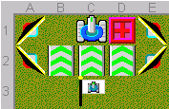

It seems that our tank was trapped on the edge of the map. But don’t worry and shoot left! The laser will be reflected by mirrors and reach the right side of the block. Then the block will tend to hit our tank. See Picture 1.2 to know what will happen exactly.

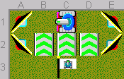

Go down. (Picture 1.3)

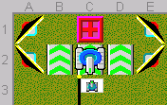

Our tank stays on C2.

Reach the flag.

In the situation of Picture 1.1, if our tank directly tries to go right, there will be no effect.

What is more, when you are riding something, you are totally safe from anti-tanks. You won’t be seen by them.

(2)How will things happen when there is ice under our tank? See Picture 2.1.

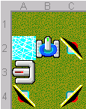

Go left and shoot right.

The tank will slide across the ice and stop on A1. See Picture 2.2.

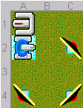

How about Picture 2.3?

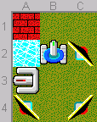

Go left and shoot right. As you expect, you will ride the AT.

(3) What will happen if your tank’s position is shot by a laser, while it is riding on something? The answer is you will die.

2. Examples

(1) Using it consecutively. See Picture 3.1.

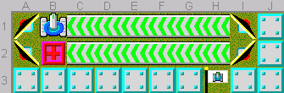

First shoot B2 to C2, go to B2. (Picture 3.2)

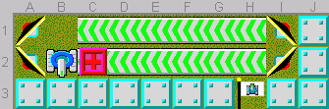

Shoot left so as to ride the block. (Picture 3.3)

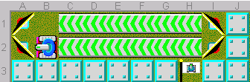

Go right. (Picture 3.4)

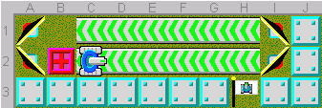

Shoot right so as to ride the block on C2. (Picture 3.5)

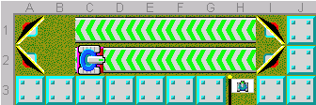

Go right. (Picture 3.6)

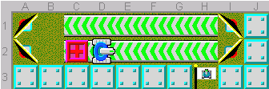

Repeat this process again and again until you reach H2. (Picture 3.7)

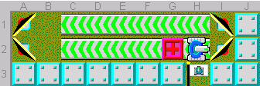

Get the flag.

(2) Face to Face. See Picture 4.1.

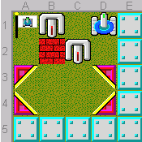

Push C2 and go to B4. (Picture 4.2)

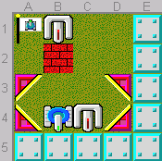

Shoot left then shoot up.(Picture 4.3)

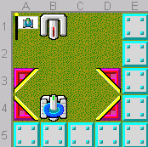

You see what? You are safe!

Kill him then reach the flag.

See Picture 5.1 as another example of “Face to face”.

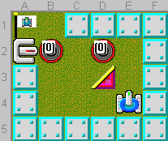

It is seem that the flag is well protected by A2. But we can push the mirror to C2 then go to B2 (appear on D2). See Picture 5.2.

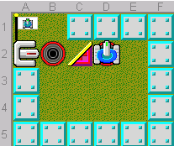

Shoot left twice then you can reach the flag. See Picture 5.3.

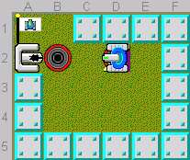

See Picture 6.1 as another example.

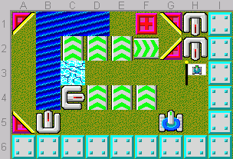

Clearly we must push B5 to H5. But if our tank directly goes to Line 2 or Line1 to shoot the mirror, the B5 AT will pass the column which our tank is on. Then that AT will see our tank and shoot us to death.

So the solution is to push C4 to C2 then go to E1. See Picture 6.2.

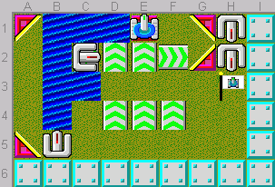

C2 AT shot the block so that we can ride it.

Shoot right to push B5 to H5. Then right to kill C2. The rest is easy.

See Picture 7.1 as another example.

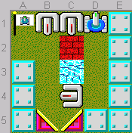

If we want to shoot B2 in “normal” ways, we have to push C4 to A2 but obviously it is impossible to win.

Shoot the bricks and shoot C4 left. Go across the thin ice. See Picture 7.2.

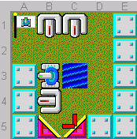

Our tank will ride B4 AT without being shot by B2, because there should be at most one laser in the map.

Of course there are still other ways to cause “face to face” situation.

(3) Dealing with ice. See Picture 8.1.

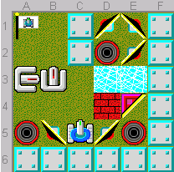

This one is a bit tricky. Let’s deduct it step by step.

#1. We must pass the defence of A3 before you reach the flag. You cannot push it up or down. It should be killed just on A3.

#2. The only way to kill A3 is to let our tank ride something in Line 3. With our materials, we have only one chance: to stand on D3 while E4 mirror is on D2, then shoot up, the laser will push the mirror to D3 too.

#3. But the problem is: at that time the D4 bricks should still exist, or else the moving mirror cannot stop on D3. How could our tank go to and stay on D3 with a mirror on D2 and bricks on D4?

#4. The problem leads to the only answer: we must stand on D2 when shooting E4 into E5! Thus at that time E2 mirror should face to southeast.

Let’s have a go. Go to E3, shoot up twice. See Picture 8.2.

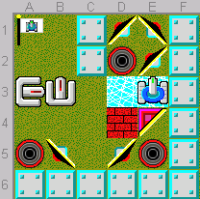

#5. Go to A5 (appear on D2). Shoot right twice so that our tank can ride the movable mirror. See Picture 8.3.

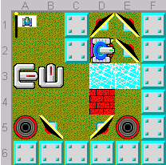

Shoot up and go to D3. See Picture 8.4.

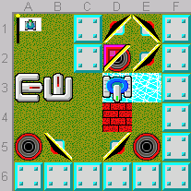

Shoot up to ride the mirror again. See Picture 8.5.

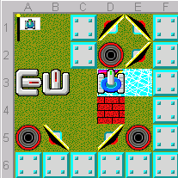

Shoot down three times and kill A3. See Picture 8.6.

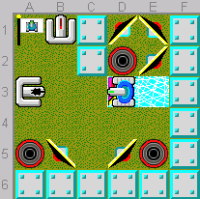

Reach the flag.

Actually, the origin level, which was harder than Picture 8.1, is like Picture 8.7.

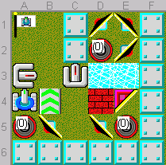

I leave the question for you to think why we still have to ride E4 TWICE since C3 can be an obstacle to make you stay on D3.

Next one is even harder. (Picture 8.8)

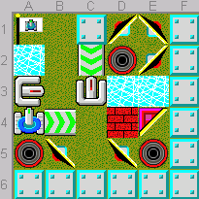

3. Lasertank Collection (You can manipulate them in your computer)

(1) Challenge-IV_0712 “without slattern” by Baumann Eduard, Difficulty: Medium. (Picture 9.1)

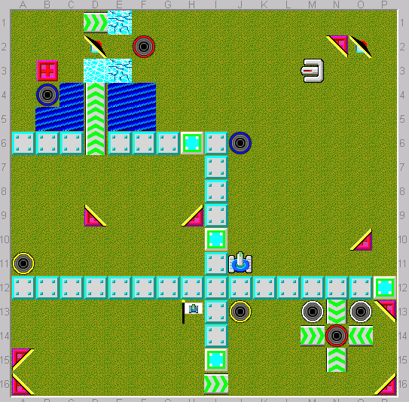

It is clear that you should climb the tank-movers in Column D so as to go to the rooms. So we should make up a laser chain turned by mirrors. By analysis we can make sure that M3 must go to D3, B3 to C3 then C4, N2 to H2. See Picture 9.2.

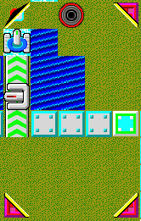

There is another problem: we need an extra movable object in the bottom rooms. Which can? It must be the N2 mirror in Picture 9.1. (M3 will go to Column D so cannot return to the red tunnel in Column F; O10 cannot be pushed down from N14 to Line 16.) But we cannot shoot it into the red tunnel too early because we should use it to climb the tank-movers in the situation of Picture 9.2. However, after our tank enters the room, there will be no opportunity to push the mirror into the tunnel. After excluding the impossible ways, there is only one opportunity! See Picture 9.3.

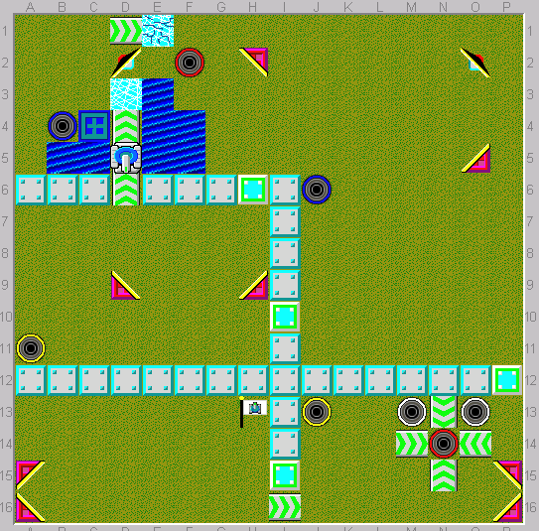

Just this moment is right to push H2 into F2. If earlier, we need it to reflect the laser chain; if later, we cannot push it into the tunnel.

The rest is much easier.

(2) #0948 “les outils suspendus” by Kheper, Difficulty: Hard. (Picture 10)

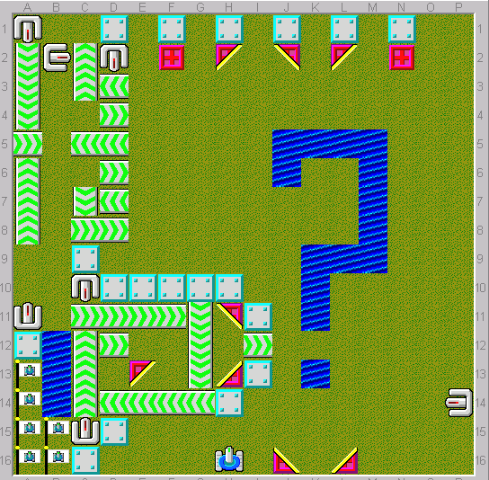

This is a very famous level in LT (in short of Lasertank) world. A large group of people got trapped in this one. It looks so easy. I had tried it time to time and finally succeeded after years.

I would like not to show the ending which may spoil your pleasure. I have given you a hint already, haven’t I?

4. Further Recommendations

(1) Challenge-III_0865 “Winter vacation 2: Dancing” by Yono in Jkt. Difficulty: Medium. (Picture 11)

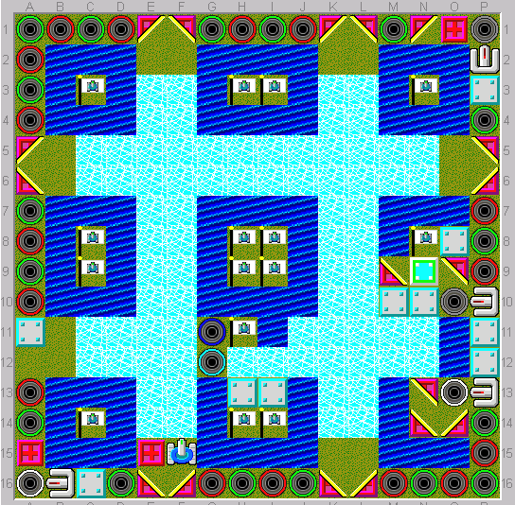

#0179 “Being an inchworm…” by Kheper, Difficulty: Deadly. (Picture 12)

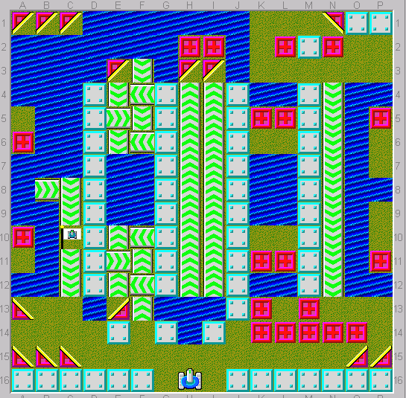

(2) #0726 “Kids>Up…Others>Down” by Kheper, Difficulty: Deadly. (Picture 13)

